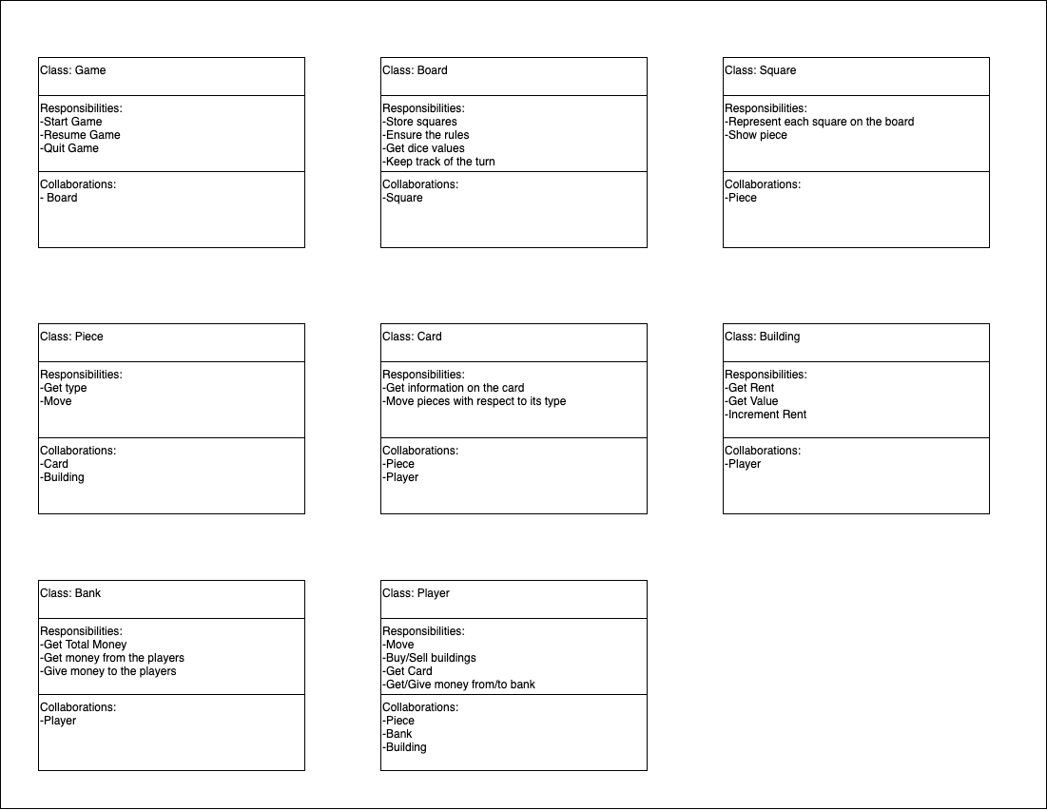**Monopoly Game CRC Cards**

**Monopoly Game Class Diagram**

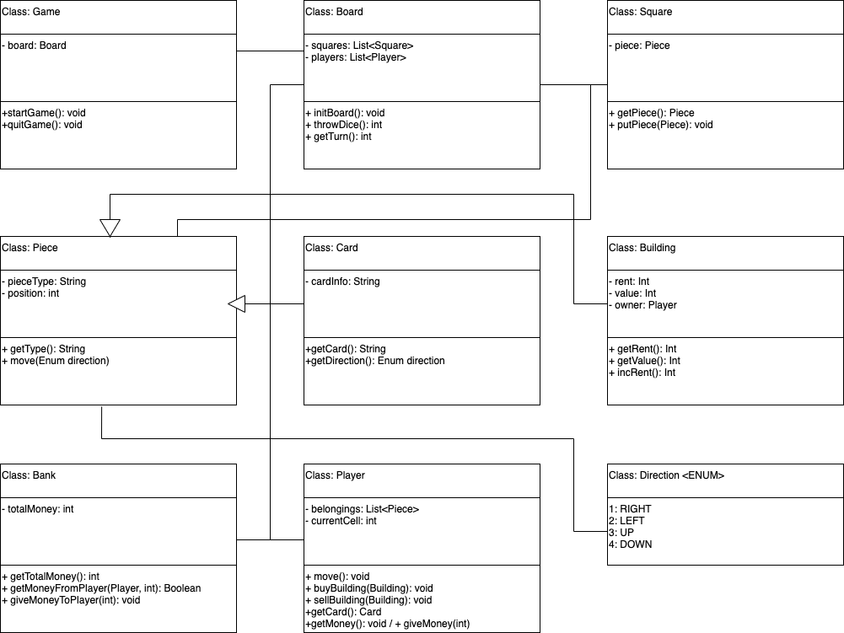

**Why the specified classes are selected?**

In my design, I tried to create the most fundamental classes and did not want to waste memory by creating for example a ‘Dice’ class; because a dice value can be generated by the Board class itself within a member method. Also, I did not create separate classes for houses, hotels etc. since those can be represented just by the building class itself.

I have a ‘Piece’ class which is the parent class of all pieces that can exist in the game. The Object-Oriented Design Pattern here is used to be able to have list of pieces stored in players since a player can have various pieces in hand.

In this class diagram, I did not specify the methods like getters, setters and draws since those are compulsory and I did not want my class diagram to seem complex.